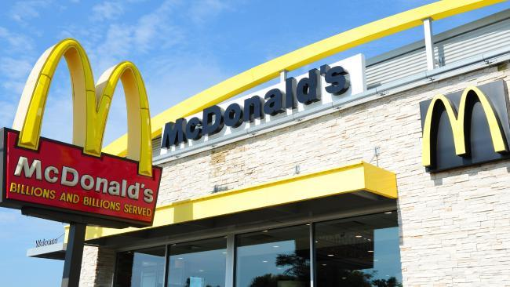
U4O1 - McDonalds
Thursday, June 29, 2017
10:31 PM
Read the article below and answer the questions that follow:

http://www.news.com.au/lifestyle/food/restaurants-bars/mcdonalds-australia-launches-table-delivery-service-and-partners-with-ubereats/news-story/1633509d4e16d719ffedeb3d85a88254

**Note: in the 2017 VCAA Sample Business Management Exam it uses the task word "Explain" 8 times! When answering questions with the task word "Explain" you have to link your answer to the case study to ensure that you get full marks for the question. When answering the below question ensure that you link your answer to the businesses and information in the article above.
Questions

- Outline the two main changes that McDonald's is proposing to introduce to it stores. Explain why McDonalds is implementing these changes.

- Describe three Key Performance Indicators that are mentioned in the article. Explain how each of these KPI's would be used to evaluate the performance of McDonald's.

- Explain three Driving Forces for Change that support the need for McDonald's to make the relevant changes.

- Describe and justify three Restraining Forces for Change that McDonald's may encounter when making the changes to its stores.

- Explain which of Porter's Generic Strategies that McDonald's uses to create a competitive advantage - Lower Cost or Differentiation.

- Explain three possible Driving Forces that could be used to support and encourage change at Coca-Cola Amatil as 'global soft-drink sales plummet'

