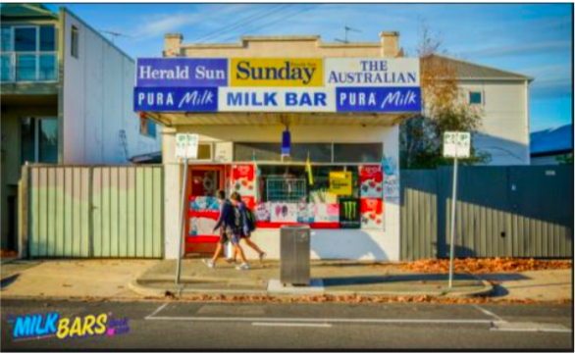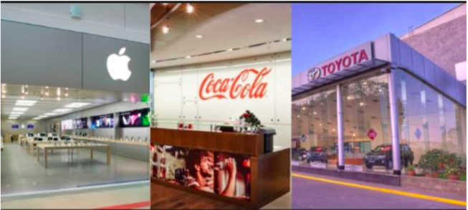

 | FEATURES | ADVANTAGES | DISADVANTAGES
SOLE TRADER

Examples:
Local Milk Bar
Gardening service
PARTNERSHIP

Examples:
Family Business

PUBLIC COMPANY
(ends in Ltd)

Examples:
Woolworths
Commonwealth Bank
PRIVATE COMPANY
(ends in Pty Ltd)

Examples:
Boost Juice
Construction Company
Social Enterprise

Examples:
First Bite
The Smith Family
GOVERNMENT BUSINESS ENTERPRISE (GBE)
Examples:
VicRoads
Australia Post

