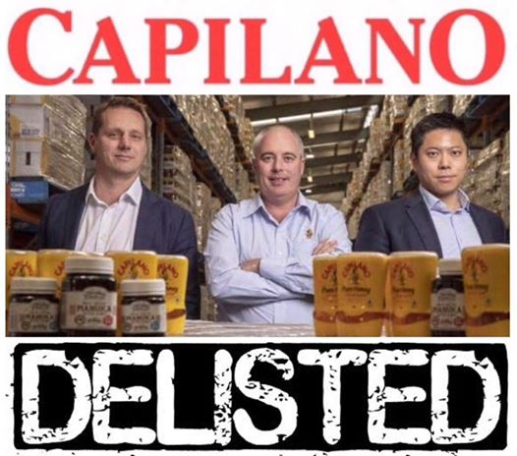
Save the Bees Australia
Like Page
December 18, 2018
On 10 December 2018 Capilano Honey Limited was officially delisted from the Australian Stock Exchange.
A private equity group specialising in China-focused agricultural exports has taken over Capilano Ltd and turned it into a private company.
Why did the Chinese aligned consortium known as Wattle Hill RHC Fund 1 and ROC Capital Pty Ltd pay $200 million dollars for Capilano and make it a private company after the the 7.30 report / Fairfax media fake honey exposé and the competition watchdog ACCC’s investigation?
Because Capilano Ltd will now make a fortune for its shareholders selling premium Australian honey to China and be free to operate without the ASX monitoring its corporate behaviour.
Capilano Ltd CEO Ben McKee told Fairfax media prior to the take over: "I think the privatised model for a company our size is more suited, than the current listed model. (Privatised) we can take long-term investments in markets and developing markets, rather than having our results analysed every six months.”
It is clear that Wattle Hill's Mr Albert Tse is now calling the shots. The Chinese aligned consortium he heads up now owns Capilano Ltd. This includes apiary sites from Queensland to Western Australia. The company is transforming into a honey marketing vehicle focused on upper middle class Chinese customers who can’t get enough of our pure natural resources.
"We want to create products with a higher margins” Mr Tse said. "Asian and Chinese consumers see this as a wellness product... and are therefore happy to pay a higher price for it.
Ben McKee from Capilano Ltd has assured Chinese consumers that Capilano Ltd will only ever sell Australian honey to the Chinese but has not given a guarantee to Australian consumers that his company will not sell Australians honey blended with foreign honey.
Coles supermarkets have stopped selling imported blends however Woolworths is still selling blends riddled with imported honey.
Despite 180,000 signatures on a petition honey in Australia still is not required to display which country the honey is from.
http://change.org/honeylabelling
The same consortium that sells premium Australian honey to China blends imported honey with Australian and sells it to Australian consumers using subsidiary brands including Allowrie, and "home brands”.
It is now more important than ever for Australians to buy honey from their local beekeeper direct.
If you don’t already have a local legend supplying you honey use the honeymap to identify one and go and say g’day
goo.gl/vfhcQs
Sharing will save the bees. 🙏🐝
Donate
Read more here on the updates in an attempt to end the suppression orders in Sîmon Mulvany .
https://www.gofundme.com/48jlk4w…

