Case Study 1.3 – Government Business Enterprises

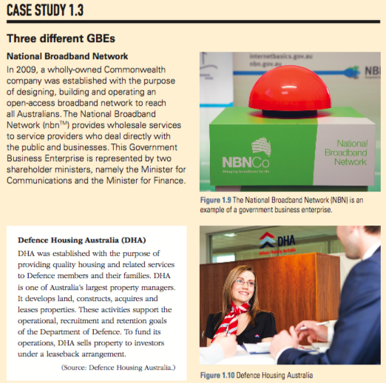
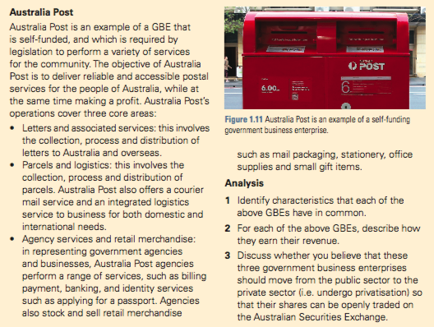

Questions
1 Identify characteristics that each of the above GBEs have in common
1

2

3

2 For each of the above GBEs, describe how they earn their revenue.
1

2

3

3 Discuss whether you believe that these three government business enterprises should move from the public sector to the private sector (i.e. undergo privatisation) so that their shares can be openly traded on the Australian Securities Exchange.

