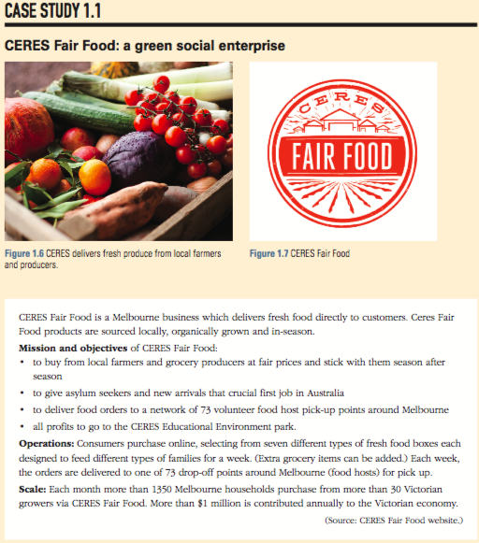

1 Briefly describe CERES Fair Food and its business model.

2 Examine the mission of CERES Fair Food. Identify and explain the public and community causes that this business is aiming to advance through its business operations.

3 Explain the criteria a business must meet in order to be classified as a social enterprise.

4 Justify whether CERES Fair Food meets all of the criteria to be classified as a social enterprise in your opinion.

5 Research and identify two other social enterprises. Write a brief description of the business, including its social objectives.

